Supplementary Material

Table S1. Total score, means, standard deviations, and Pearson’s correlations for the total sample (n = 3186).
Item | M | SD | 1 | 2 | 3 | 4 | 5 | 6 | 7 | 8 | 9 | 10
1 | 2.32 | 1.09
2. | 2.24 | 1.07 | .62
3. | 2.23 | 1.08 | .54 | .68
4. | 1.95 | 1.04 | .44 | .54 | .64
5. | 2.24 | 1.12 | .41 | .45 | .53 | .46
6. | 3.10 | 0.97 | .36 | .32 | .43 | .33 | .46
7. | 2.21 | 1.07 | .45 | .54 | .55 | .48 | .58 | .43
8. | 2.30 | 1.09 | .47 | .58 | .58 | .49 | .61 | .44 | .72
9. | 2.47 | 1.16 | .34 | .45 | .45 | .34 | .41 | .41 | .50 | .58
10. | 2.52 | 1.19 | .45 | .35 | .40 | .32 | .39 | .39 | .35 | .37 | .34
total score | 23.57 | 7.82 | .71 | .77 | .80 | .70 | .74 | .62 | .78 | .81 | .67 | .62
Note. All correlations were statistically significant a p < .001

Table S2. Total score, mean and standard deviations in males (n = 2175) and females (n = 1011)
Item | M_{males} | SD_{males} | M_{females} | SD_{females} | t-test | p | Cohen’s d
1 | 2.31 | 1.08 | 2.33 | 1.11 | .31 | ns | .01
2. | 2.26 | 1.07 | 2.20 | 1.06 | 1.49 | ns | .06
3. | 2.25 | 1.07 | 2.21 | 1.10 | .81 | ns | .03
4. | 1.94 | 1.04 | 1.97 | 1.04 | .83 | ns | .03
5. | 2.17 | 1.10 | 2.40 | 1.14 | 5.40 | < .001 | .21
6. | 3.08 | 0.95 | 3.15 | 1.00 | 1.86 | ns | .07
7. | 2.20 | 1.07 | 2.21 | 1.07 | .17 | ns | .01
8. | 2.29 | 1.08 | 2.32 | 1.09 | .77 | ns | .03
9. | 2.45 | 1.15 | 2.52 | 1.16 | 1.53 | ns | .06
10. | 2.55 | 1.18 | 2.46 | 1.22 | 1.94 | ns | .03
total score | 23.49 | 7.68 | 23.76 | 8.12 | .90 | ns | .03
Note. Bonferroni-Holm correction was applied

Table S3. Total score, means and standard deviations across age groups, namely adolescents, young adults, adults, and older adults.
Item | M_{ADO} | SD_{ADO} | M_{YA} | SD_{YA} | M_{ADU} | SD_{ADU} | M_{OA} | SD_{OA} | F | p | η² | Post-hoc
1 | 2.02 | 1.08 | 2.21 | 1.06 | 2.41 | 1.09 | 2.39 | 1.10 | 11.35 | <.011 | .011 | ADO, YA < ADU, OA
2. | 2.23 | 1.10 | 2.16 | 1.05 | 2.25 | 1.07 | 2.36 | 1.09 | 5.10 | <.022 | .005 | YA < OA
3. | 2.36 | 1.15 | 2.18 | 1.07 | 2.27 | 1.08 | 2.25 | 1.07 | 2.12 | 1 | .002
4. | 2.06 | 1.09 | 1.97 | 1.03 | 1.95 | 1.04 | 1.87 | 1.04 | 1.67 | 1 | .002
5. | 2.42 | 1.23 | 2.29 | 1.12 | 2.26 | 1.11 | 2.07 | 1.08 | 7.13 | <.011 | .007 | ADO, YA, ADU > OA
6. | 3.18 | 0.97 | 3.10 | 0.95 | 3.12 | 0.96 | 3.04 | 1.01 | 1.16 | 1 | .001
7. | 2.15 | 1.14 | 2.17 | 1.08 | 2.24 | 1.06 | 2.20 | 1.06 | 1.04 | 1 | .001
8. | 2.34 | 1.14 | 2.29 | 1.08 | 2.35 | 1.09 | 2.22 | 1.07 | 1.82 | 1 | .002
9. | 2.47 | 1.20 | 2.50 | 1.16 | 2.46 | 1.16 | 2.42 | 1.14 | .75 | 1 | .001
10. | 2.38 | 1.24 | 2.40 | 1.19 | 2.61 | 1.18 | 2.60 | 1.16 | 7.70 | <.011 | .007 | YA < ADU, OA
total score | 23.63 | 8.33 | 23.27 | 7.64 | 23.93 | 7.91 | 23.44 | 7.86 | 1.52 | 1 | .001
Note. ADO: adolescents; YA: young adults; ADU: adults; OA: older adults. p-values were adjusted for Bonferroni-Holm correction.

Table S4. Means and standard deviations in individuals at low risk (n = 1631) and high risk (n = 1555)
Item | M_{lowrisk} | SD_{lowrisk} | M_{highrisk} | SD_{highrisk} | t-test | p | Cohen’s d
1 | 1.67 | .78 | 2.99 | .95 | 42.8 | < .001 | 1.52
2. | 1.55 | .70 | 2.96 | .91 | 49.3 | < .001 | 1.75
3. | 1.51 | .64 | 3.00 | .91 | 53.8 | < .001 | 1.91
4. | 1.36 | .60 | 2.56 | 1.04 | 39.9 | < .001 | 1.42
5. | 1.56 | .75 | 2.95 | .98 | 45.0 | < .001 | 1.60
6. | 2.62 | .96 | 3.60 | .66 | 33.4 | < .001 | 1.18
7. | 1.52 | .71 | 2.92 | .89 | 49.1 | < .001 | 1.74
8. | 1.56 | .71 | 3.08 | .85 | 54.7 | < .001 | 1.94
9. | 1.83 | .94 | 3.14 | .97 | 38.4 | < .001 | 1.36
10. | 1.91 | 1.01 | 3.15 | 1.01 | 34.3 | < .001 | 1.22
Note. Bonferroni-Holm correction was applied
Figure S1. Nonparametric bootstrapped confidence intervals of estimated edges. The red line represents the estimated edge, while the dark area indicates the 95% boostrap confidence interval.

Figure S2. Nonparametric bootstrapped difference test for the edges. Gray boxes indicate no significant difference, whereas black boxes indicate statistically significant difference (p < 0.05). Diagonal color and saturation represent the magnitude and direction of each estimated edge.

Figure S3. Nonparametric bootstrapped difference test for the strength index. Gray boxes indicate no significant difference, whereas black boxes indicate statistically significant difference (p < 0.05). Diagonal values represent the strength score of each node.
Figure S4. Network estimated on raw data and cross-validated predicted network

Figure S5. Strength computed on raw data and based on cross-validation
Figure S6. Network visualization by gender.
Figure S7. Strength scores by gender
Figure S8. Nonparametric bootstrapped confidence intervals of estimated edges, by gender. The red line represents the estimated edge, while the dark area indicates the 95% boostrap confidence interval.
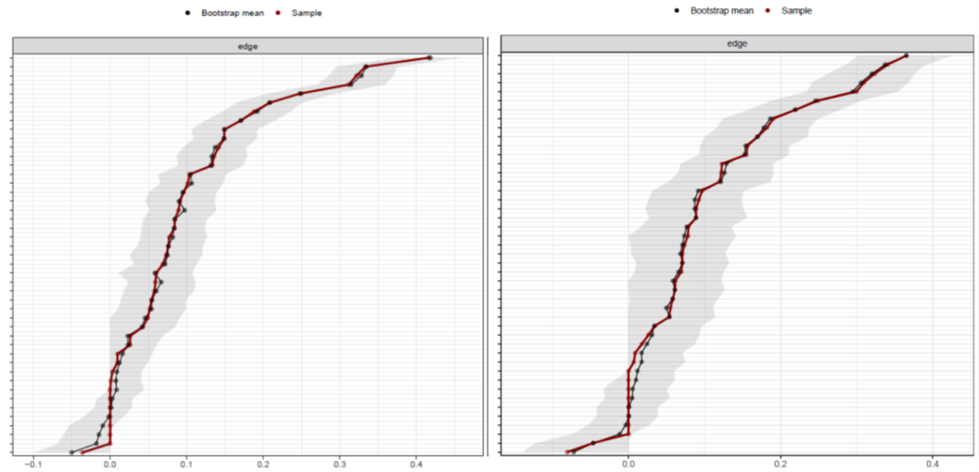

Figure S9. Nonparametric bootstrapped confidence intervals of estimated edges across the five age groups. The red line represents the estimated edge, while the dark area indicates the 95% boostrap confidence interval.

Figure S10. Moderated network of hypersexuality, where age serves as moderator
.

Figure S11. Network visualization by risk status
.

Figure S12. Nonparametric bootstrapped confidence intervals of estimated edges, by risk status. The red line represents the estimated edge, while the dark area indicates the 95% boostrap confidence interval.
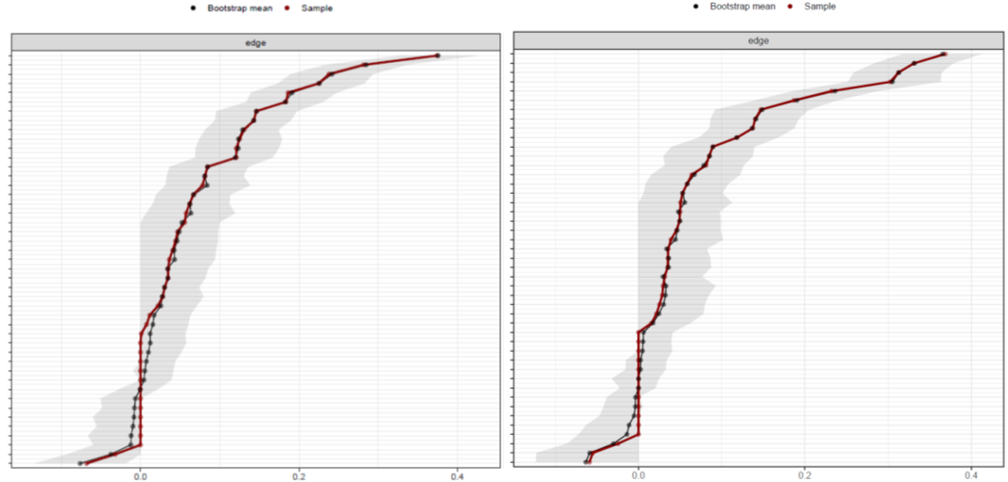

Figure S13. Strength scores by risk status

